AI-Assisted Local Development: React Application

Mohammed Amer
IWU
3FA2026 AI Integration Capstone
SEPT 13, 2026

Introduction
This assignment focused on transitioning from browser-based Claude Artifacts to a professional local development environment using an AI-powered IDE. The main objective was to experience how AI coding assistants can support project organization, application development, debugging, and local testing. The project was developed as a React application using Vite, Node.js, and npm.
IDE Setup and Development Path
For this project, I used Visual Studio Code as the development environment together with AI-assisted development techniques. Node.js and npm were also used to install dependencies and run the application locally (Fallow, 2026). I selected Path B, which involved building a fresh application based on the assignment requirements rather than directly migrating an existing Claude Artifact.
The application was organized into multiple files and components, including App.jsx, main.jsx, Dashboard.jsx, TaskForm.jsx, TaskList.jsx, TaskCard.jsx, Header.jsx, and Footer.jsx. This structure improved separation of concerns and made the application easier to maintain.
AI Prompts and Assistance
Several AI prompts were useful during development. These included requests to create a professional React project structure, run the application locally, add validation, implement loading and error states, make the interface responsive, and save task information using local storage. AI assistance was particularly useful when troubleshooting the blank localhost page and identifying that React needed to be tested separately from the larger application.
Claude Artifacts vs Local Development
Claude Artifacts provides a convenient browser-based environment for quickly creating and demonstrating applications. However, local development provides greater control over project files, dependencies, folder organization, debugging, and future development. The local environment also provides a more realistic software development workflow.
Challenges and Conclusion
The main challenge was initially receiving a blank localhost page because of an application configuration or component issue. AI-assisted troubleshooting helped isolate the problem by testing React independently (Bawa & Bhat, 2026). Overall, the assignment demonstrated that AI agents can significantly support development while still requiring the developer to test, verify, and understand the generated project.
Time Spent
Approximately 30 minutes were spent setting up the environment, 45 minutes developing the application, and 30 minutes testing and troubleshooting the local application.
Visual Studio
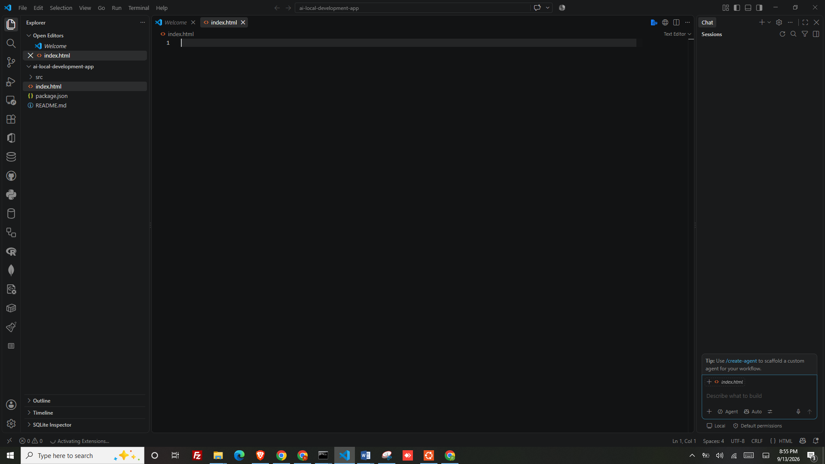
Running Code
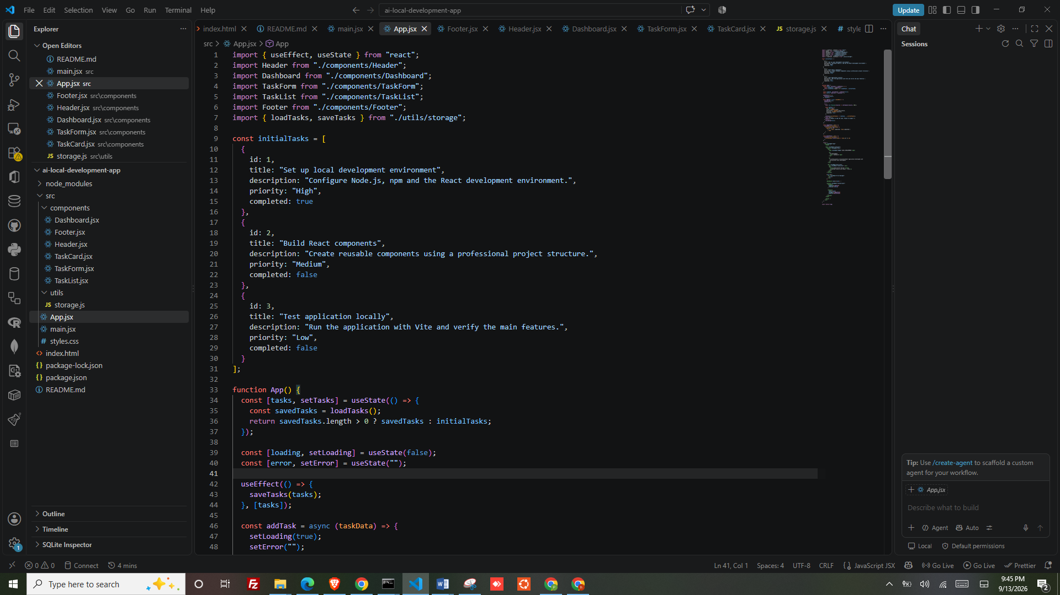
Ruung in browswer
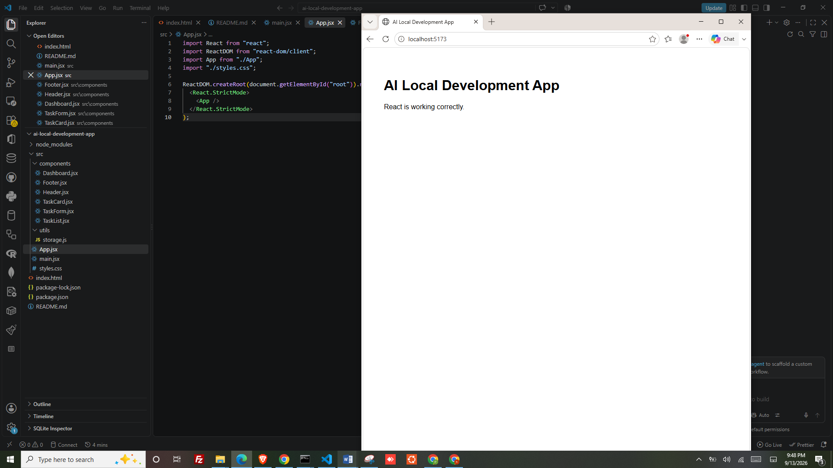

References
Bawa, P., & Bhat, S. S. (2026). An Empirical Study on Runtime Performance and AI-Assisted Development Efficiency: A Comparative Analysis of Angular, React, and Next. js. React, and Next. js (August 02, 2026).
Fallow, D. (2026). Utilising AI to Assist Front-end Development of a React Native Mobile Application.

